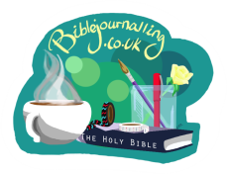
Cultivating an ‘Attitude of Gratitude’
- Psalm 95:1-7
- Psalm 100
- 1 Chronicles 16:31-34
- Revelation 11:17
These passages show people at different points in Biblical history expressing their thanks to God. They provide a useful starting point on our gratitude journey by inviting us to give thanks in different ways as part of our daily worship. What would it look like if we were to live life in an ‘attitude of gratitude’? Would the world start to look different? If you are committing to the month-long daily gratitude challenge, you will begin to find the answers to these questions.
The Psalms have been used in corporate worship for 1000s of years and have a lot to teach us about how we give thanks, both as individuals and in our worship together. 1 Chronicles 16 shows us the practice of thanksgiving in worship in action and the passage in Revelation gives us a picture of heaven and the eternal thankfulness before the throne of God.
You could choose just one of the Psalms to work with, or cover all 4 passages over several days. You could start by covering your page with some pale paint or paper to make a background, or just put some washi tape round the edges. As you read and think about the passage, do any of the things mentioned resonate with you? Think about what makes you feel thankful. We are not looking for things we ought to be thankful for, but things we actually are thankful for! Choose colours that make you feel positive and write or represent these on your page.
How will you respond? The psalms give us some suggestions. Illustrate your page accordingly, or start a new page with images of response. Use any other images from the passage that strike you. You may end up with quite a lot of sheep! Or you may not. Use the images that speak to you and any others that come to mind.

